0 | 2021.07.01 |  | First draft
Manager |  | . . . |  | Director | JIEUN BAE  . . . | CEO | . . .

§ 1.
General rules of travelling on business

- The Regulations define the rules of making business trips in CTR EUROPE GMBH Branch in Poland (hereinafter referred to as the "Employer",) and are binding for all its employees (hereinafter referred to as the "Employees").
- When planning a business trip, each Employee is obliged to follow the principle of rationalisation and minimisation of expenses. The business trip should meet the legitimate needs of the employer.
- Responsibility for the legitimacy of the delegation of an employee on business travel and the conditions for its conduct shall be borne by the delegator referred to in point 4 below.
- The following are authorized to delegate an Employee by approving the appropriate business travel order form: General Director JIEUN BAE
- For a business trip carried out at the time and place specified by the Employer, the Employee is entitled to:
  - per diems - intended to cover increased costs of food,
  - reimbursement of the costs of travel, accommodation, travel by local means of transport,
  - reimbursement of other documented expenses,
  - reimbursement of other documented expenses, under the terms of these Regulations.
- Business trip orders should be made in writing or electronically.

§ 2.
Domestic business trips

- A domestic business trip is a trip of an Employee outside the town where the Employer's seat or the Employee's permanent place of work is located, in order for the Employee to perform a business task at the Employer's order. The destination of a domestic business trip is a place located in the territory of the Republic of Poland.
- A part of a foreign trip shall also be regarded as domestic business travel:
  - in the case of travel by land in the territory of the country (until crossing the border with the Republic of Poland)

  - by sea from the place of departure of the business trip in the territory of the country until the departure of the ship/ferry from the Polish port, and on the return journey from the moment the ship/ferry enters the first Polish port.
  - by air/air - until the aircraft takes off from the last airport in the territory of the Republic of Poland, on the way back from the moment of landing at the first airport in the territory of the Republic of Poland.
- A domestic business trip is preceded by the Employee submitting a business trip plan to the Employer on a form "Business trip approval request", which must contain such information as the Employee's data (name, surname, position), the purpose of the business trip, the place of commencement and destination of the business trip, its duration, means of transport (train, car, other) and their class (standard – economy or 2nd class), tasks to be performed or the basis for the call or invitation, the amount of any advance payment for the costs of the business trip, not exceeding the calculated expenses.
- The place of commencement of the business trip shall be the place where the permanent place of work of the Employee as specified in the contract of employment is located, unless the Employee leaves from his/her place of residence, which is located along the route of the business trip. In such case, the place of commencement of the business trip shall be the place where the Employee's place of residence is located.
- The date of commencement and termination of the trip shall be determined by the Employee according to business trip schedule.
- In the case of using public means of transport, the business trip commences at the time of departure of the train, bus (or other vehicles), departure of the plane, departure of the ship/ferry, if the means of transport departs, leaves or sails with a delay, and the employee waits for departure, departure or sailing at the place of commencement of the business trip, then the business trip commences at the time of the scheduled departure of the means of transport.
- In the case of using non-public means of transport (company or private car), the business trip starts at the time of departure from the place of departure, i.e. the Employer's headquarters or the Employee's place of residence (if he drives a private car from his place of residence).
- Business travel ends in the case of using public means of transport - at the moment of arrival of the train, bus (or other vehicles), arrival of the plane, arrival of the ship/ferry to the place from which the business travel started; if the means of transport arrives, arrives or arrives with a delay in relation to the planned time, the travel ends at that moment.

- In case of using non-public means of transport (company or private car) - the business trip ends when the car returns to the place of departure, i.e. employer's headquarters or employee's place of residence (if he/she drives a private car from his/her place of residence or returns in a company car but directly to his/her place of residence).
- The allowance during domestic travel is PLN 30 per day during a business trip, subject to the following paragraphs.
- The allowance shall be calculated for the time from the beginning of the journey (departure) to the return (arrival) after the performance of the task, as follows:
  - if the journey lasts no longer than 24 hours and is:
    - less than 8 hours - no allowance is payable
    - b) from 8 to 12 hours - a 50% allowance is due
    - over 12 hours - full allowance is due
  - if the journey lasts longer than 24 hours, a full daily allowance is due for each 24 hours, and for each incomplete 24 hours started:
    - up to 8 hours - 50% per diem is due
    - over 8 hours - full daily allowance is due
  - no daily allowance is due:
    - for the time of delegation to the place of permanent or temporary residence of the Employee
    - if the Employee is provided with free full board.
- The amount referred to in section 10 of this paragraph shall be reduced by the cost of the provided free full-day meal, assuming that each meal constitutes respectively:
  - breakfast - 25% of the per diem,
  - lunch - 50% of the daily allowance
  - dinner - 25% of the daily allowance.
- In the case of an Employee using a hotel service in which meals are provided, the provisions of section 12 of this paragraph shall apply accordingly.
- Travel costs
  - The Employer only accepts costs of transportation in economy or 2nd class.
  - The costs of travel depend on the means of transport used by the Employee during the business trip; the Employee shall be obliged to enter the type of means of transport on the "Business Trip Order" form

  - the reimbursement of the travel costs shall include the ticket price of a particular means of transport together with related additional charges, including seat tickets taking into account the employee's allowance for a particular means of transport, regardless of the reason for which the allowance is granted
  - the reimbursement of the travel costs shall not be due if the means of transport is provided by the employer or the inviting party
  - at the request of the Employee, the Employer may agree to allow the Employee to travel by car, motorcycle or moped not owned by the employer; in this case the Employee is entitled to reimbursement of travel costs in the amount equal to the product of the kilometers travelled and the rate per one kilometer of travel established by the employer, which may not be higher than specified in the regulations issued under the Road Transport Act.
- Costs of commuting to work during a business trip:
  - if in the place of posting an employee has to commute from the place of residence (e.g. hotel) to the place where he/she performs the task assigned to him/her as part of the business trip, the Employee shall be entitled to a lump sum to cover the costs of commuting by means of local transport in the amount of 20% of the per diem for each commenced day of stay during the business trip.
  - the lump sum shall not be paid to the Employee who did not incur the travel costs.
- The rules for reimbursement of the costs of accommodation during business trips:
  - for overnight accommodation in a hotel or other facility providing hotel services, the Employee shall be entitled to reimbursement in the amount specified in the bill or VAT invoice, however, not more than PLN 600.00 for accommodation per night.
  - if no VAT invoice for accommodation is presented, the employee shall be entitled to a lump sum for each overnight stay amounting to 150% of the per diem;
  - the employee shall not be entitled to reimbursement for accommodation if the accommodation is provided by the employer or the inviting party;
  - a lump sum for overnight stay shall be paid if the overnight stay lasted at least 6 hours between the hours of 10 p.m. and 6 a.m;
  - the reimbursement of accommodation costs or a lump sum for accommodation is not due for the time of travel (transit) taking place during the hours referred to in point 4) above, and also if the Employer considers it possible for the employee to return to the place of permanent or temporary residence on a daily basis

- Trip advance:
  - the Employer, upon the request of the Employee, shall be obliged to grant an advance for necessary travel expenses; the advance shall cover only expenses related to the costs of the business trip;
  - the form in which the advance is granted, as well as its amount and date, shall be recorded by the accounting department.
- Settlement of travel expenses:
  - the Employee shall be obliged to settle all the costs of the business trip within 7 calendar days from the date of completion of the trip - if this deadline is not met, the advance shall be deducted from the Employee's remuneration on the next pay date
  - after returning from a business trip the Employee fills in a travel costs form, stating the actual costs incurred and the per diems he/she is entitled to; the employee attaches documents to the business trip cost statement, in particular bills, VAT invoices, tickets confirming the individual expenses (except for the expenses covered by the lump-sum payments)
  - if the VAT bill/invoice for accommodation does not clearly state that breakfast was included in the price of accommodation, then the VAT bill/invoice should include a statement: "Breakfast included in the price of accommodation" or "Price of accommodation without breakfast"
  - The invoice shall be submitted by the Employee to the person who delegated him/her for verification and acceptance as to its contents
  - the Employer performs a formal and accounting control of the business trip costs, verifies the accounts and then makes the payment
  - Advance payments for business travel costs not settled on time shall be deducted from the employee's remuneration in accordance with the principles set out in Article 87 of the Labour Code
  - the complete documentation related to the settlement of the business trip costs is stored by the Employer for the period resulting from the applicable regulations.

§ 3.
Foreign business trips

- A foreign business trip is the performance by an Employee at the Employer's request of a business task outside the borders of the Republic of Poland.

- The rules of conduct applicable to domestic business trips shall be applied to the section of the business trip performed in Poland up to the point of crossing the border of the country.
- Foreign business travel order:
- a foreign business trip shall be preceded by the Employee submitting a business trip plan to the Employer on a form "Business trip approval request", which must contain, inter alia, such information as the Employee's data (name, surname), the purpose of the trip and the destination of the trip, the date of the business trip, the means of transport (train, car, other) and their class (standard – economy or 2nd class), the task to be performed or the basis for the call or invitation
- all applications for a business trip abroad are registered by the Employee electronically in the system
- The duration of an Employee's stay abroad:
- the date of commencement and completion of the trip shall be determined by the Employee based on business schedule ; the time of the Employee's stay abroad shall be counted when the trip is made by means of communication
    - by land - from the moment of crossing the Polish border on the way abroad to the moment of crossing the Polish border on the way back home
    - by air - from the moment the plane takes off on the way abroad from the last airport in the country to the moment the plane lands on the way back to the first airport in the country
    - by sea - from the moment the ship (ferry) leaves the Polish port to the moment the ship (ferry) enters it on its way back to the Polish port
- the amount of per diem for a day of travel in individual countries is specified in the appendix to the Regulation of the Minister of Labour and Social Policy of 29 January 2013 on the entitlements to be paid to an employee working in a state or local government unit of the budgetary sphere for business travel
- the allowance shall be in the amount applicable to the destination country of travel and shall be calculated as follows:
- a full day's allowance is payable for each day of travel,
- for an incomplete day of travel:
- up to 8 hours - one third of the daily allowance is due,
- over 8 to 12 hours - 1/2 of the daily allowance is payable
- over 12 hours - full daily allowance.

- Limitations and changes to the amount of a per diem:
- an Employee who was provided, during a trip abroad, with free full-day board is entitled to 25% of a per diem fixed in accordance with the preceding provisions
- the amount of a per diem shall be reduced by the cost of the provided free board, assuming that each meal constitutes respectively:
- breakfast - 15% of the per diem,
- lunch - 30% of the daily allowance
(c) dinner - 30% of the daily allowance
3) if an Employee uses a hotel service where meals are provided, the provisions of item 2 shall apply accordingly
4) for each day of stay in a hospital or other treatment facility abroad, the Employee shall be
entitled to 25% of the per diem.
- Travel costs:
  - the means of transport, its standard and class shall be determined by the Employer – the Employer only accepts economy and 2nd class of transportation
  - the reimbursement of the travel costs includes the price of the ticket of the means of transport specified by the employer together with additional charges, taking into account the employee's allowance for a given means of transport, regardless of the reason for which such allowance is granted; if the employee, with the consent of the employer, uses his/her own car, motorcycle or moped, the employee is entitled to reimbursement of the travel costs in the amount being the product of the kilometers travelled and the rate per 1 km of travel established by the employer, which cannot be higher than that specified in the regulations issued on the basis of the Road Transport Act.
- Commuting allowances:
- the Employee shall be entitled to a lump sum to cover the costs of commuting from and to the railroad station, bus station, airport or sea port in the amount of one per diem in the destination abroad and in any other place where the employee used to stay overnight;
- to cover the costs of travel by means of local transport the employee is entitled to a lump sum amounting to 10% of the per diem for each started day of the stay during the trip;
- the above-mentioned lump sums are not due if:
    - the Employee travels by car, motorcycle or moped (company or private),
    - the foreign party provides free transport,

    - the Employee does not incur the costs for which the indicated lump sums are intended to cover.
- Accommodation costs:
- the Employee shall be entitled to reimbursement for accommodation costs in the amount as evidenced by a bill or VAT invoice within the limits of the limit set for this purpose in the Annex to the Regulation;
- if no VAT invoice for accommodation is submitted, the employee is entitled to a lump sum amounting to 25% of the limit; however, the lump sum is not payable for the travel time;
- The Employer may agree to reimburse the cost of hotel accommodation, as confirmed by a VAT bill/invoice, in an amount exceeding the limit;
- if the Employer or the foreign party provides the employee with overnight accommodation, then no reimbursement for overnight accommodation or a lump sum is payable.
- Advance payment:
- The Employer shall grant the Employee an advance in foreign currency for the necessary costs of the foreign trip in the amount resulting from the preliminary cost calculation;
- upon the Employee's consent, the advance referred to in subsection 1 may be paid in Polish currency, in the amount equivalent to the advance due to the employee in foreign currency, according to the average PLN exchange rate in relation to foreign currencies set by the National Bank of Poland on the date of payment of the advance.
- Settlement of travel costs and advance payment:
- The Employee shall be obliged to settle the travel costs within 7 calendar days from the date of completion of the travel; in case of failure to meet this deadline, the advance payment shall be deducted from the employee's remuneration on the nearest payment date;
- the Employee attaches documents (bills, VAT invoices, tickets) confirming particular expenses to the travel cost settlement; it does not apply to allowances and expenses covered by lump-sums; if it was impossible to obtain the document, the employee submits a written statement on the expenditure incurred and reasons for the lack of the document
- documents confirming the settlement of travel costs are checked by the HR Office in terms of document compliance and formal/accounting compliance
- in the case of receiving an advance to cover the costs of a business trip abroad, the employee is obliged to settle it in the currency of the received advance, in convertible currency or in the Polish currency according to the average exchange rate as of the date of its payment

- a business trip application submitted by the employee for settlement incorrectly (untimely), erroneously (wrong data) and without the attached documents is not the basis for the payment of the costs of the business trip for the reporting month
- an employee returning from a business trip abroad is obliged to submit a written report on the business trip made within 7 days; the report should be approved by the delegator.

§ 4.
Final provisions

      - Any change to the provisions contained in these Regulations shall require an annex in writing under pain of nullity.
2. In matters not regulated herein, the applicable provisions of law shall apply:
1) the Act of 26 June 1974. - Labour Code (Journal of Laws of 2020, item 1320),
2) Regulation of the Minister of Labour and Social Policy of 29 January 2013 on the amounts due to an
employee working in a state or local government unit of the budgetary sphere for business travel
(Journal of Laws, item 167).

[Appendix 1] Amount of per diem for a day of travel in individual countries
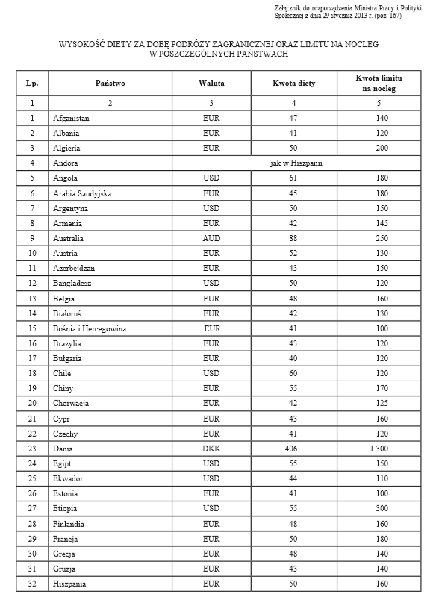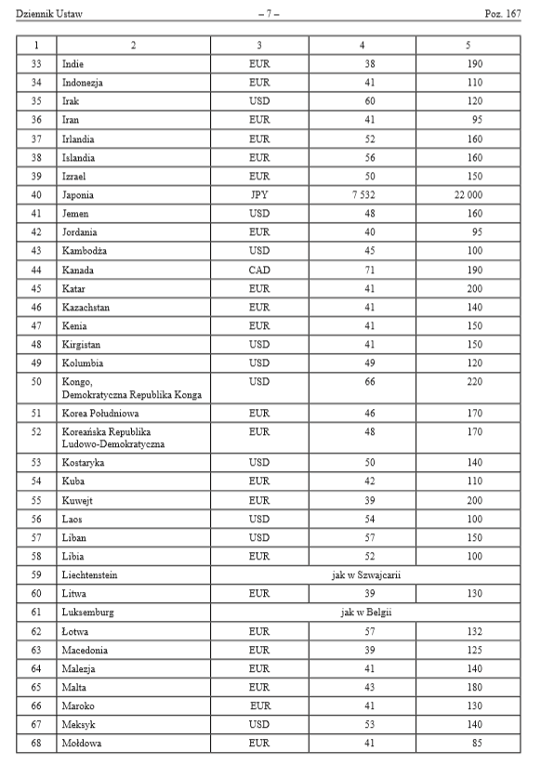
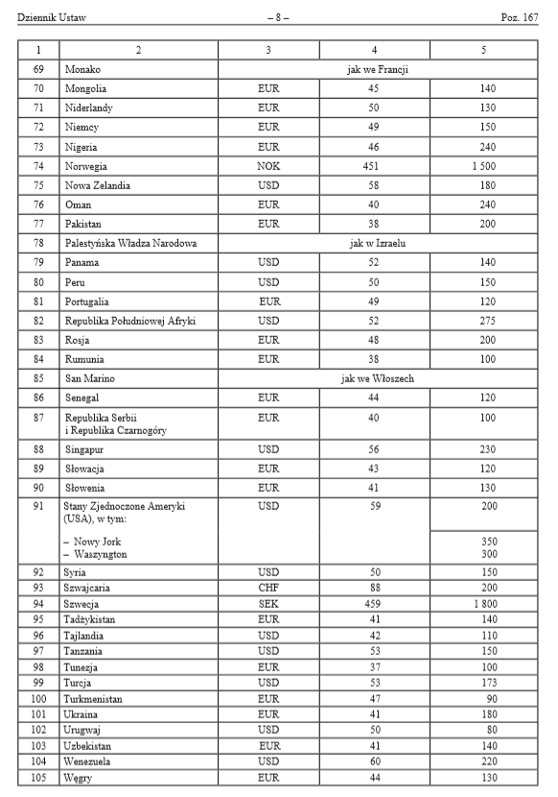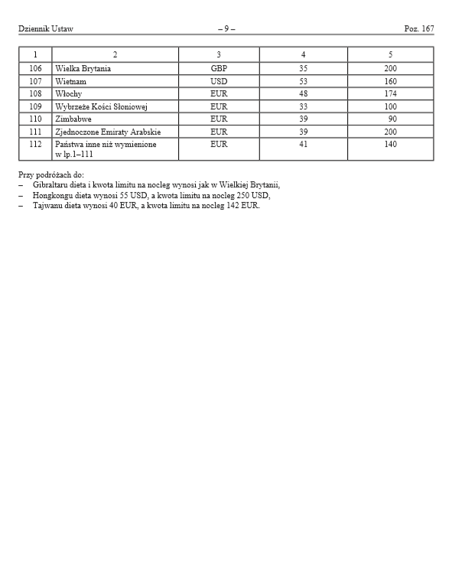

[Appendix 2] Business trip template
